Systems Analysis and Design book

# Mission Statement

|  |  |  |  |  |  |  |  |
| --- | --- | --- | --- | --- | --- | --- | --- |
|  | Company /Industry | Mission Statement | Strategy/Value Proposition  (Satisfying user needs) | | Strategic Objectives Initiatives, Growth strategy | User/ Product Model | Key Business/ System Requirements |
|  |  |  | Needs, utility, efficiency, UX, Value/price | |  |  |  |
| 1 | Uber | Developing technology to help move people all around the world | Cheap/fast/high Quality taxi & ride sharing service  Providing a source of income for entrepreneurs | Uber Town Car  Uber X  UberPOP  Uber SUV  Uber Helicopter | | Primarily smartphone ride service app and online web site | Zero inventory,  High transaction and high margin.  Commission 20% to Uber  Network Orchestrator  Online platform & Infrastructure |
| 2 | Netflix |  |  | |  |  |  |
|  |  |  |  | |  |  |  |
|  | Start-up IT |  | Server | |  |  |  |
|  | Knowledge-base site |  |  | |  |  |  |
|  | Research Databases |  |  | |  |  |  |
|  | Analytics |  | GPU, Cluster | |  |  |  |
|  | Software Development |  | Web server/Cloud/ frameworks/ patterns  /services/microservices | |  |  |  |
|  | Iot research  platform |  |  | |  |  |  |
|  | Mobile app |  |  | |  |  |  |
|  | Homekit |  | Energy, water, temp, air-quality, inventory | |  |  |  |
|  | Flexs |  | CAD  Microcontroller  Video controller  Display | |  |  |  |

Form

Function

Entities – parts/modules/subroutines

Form (entities)

Function (entities)

Relationships

Emergent properties

General requirements

Outputs:

Systems specification

Procurement list

Detail design specification

Systems Specifications

User requirements-> Operational and functional analysis/modeling

Performance/physical characteristics, regulatory requirements, effectiveness, reliability, maintenability, usability (Human Factors)

Benefits

Provent cyber threats

Protect customer data

Storae contents

Acquire contents

Stream video + Audio

Great login/account

Serach titles

Recommendations sys

Bill customer

cookies

Html5-web knowledgebase

Backup, VPN, Develops

Storage

Doc control

Deve test

Web

e-mail

security

proviate

cloud/apps

hypbrid

local

AWS

GPU

# Project Management

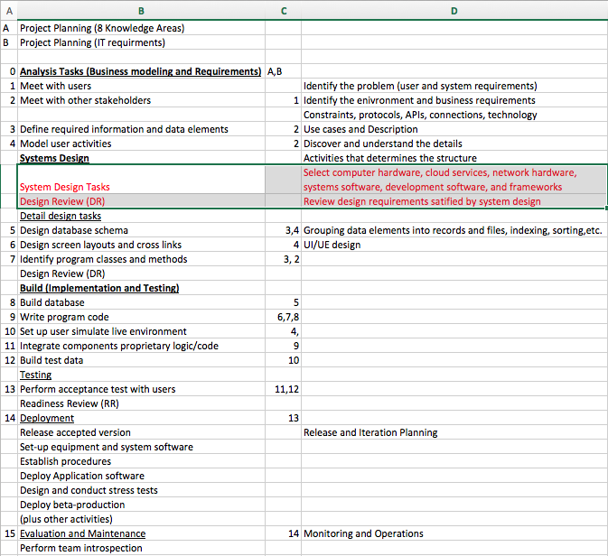

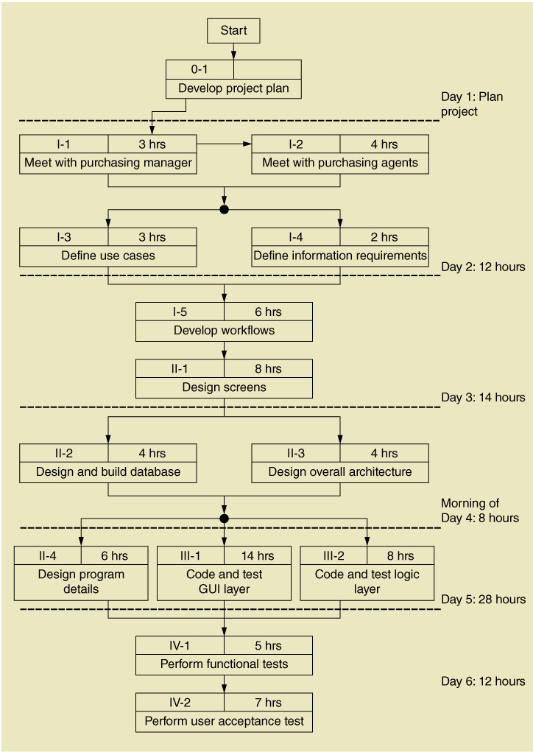

# IT Management

## Analysis and Design Tools

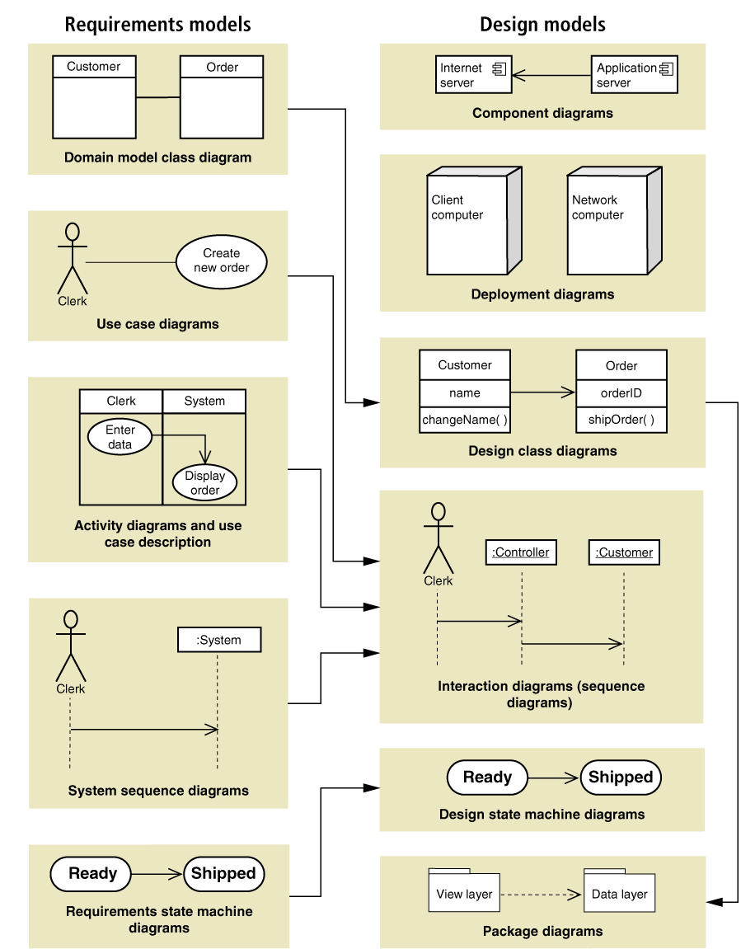

# SDLC

Unified Process

Chp1 chart – not this one

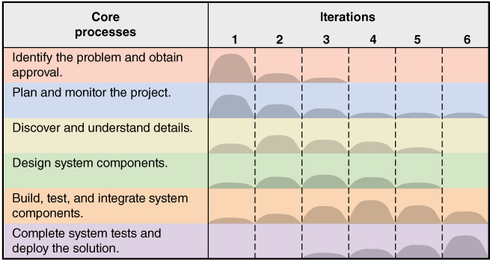

# Analysis (Business modeling and Requirements)

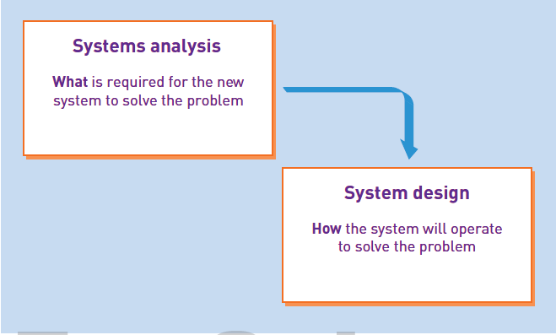`

## Meet with users

## Meet with other stakeholders

## Define required information and data elements

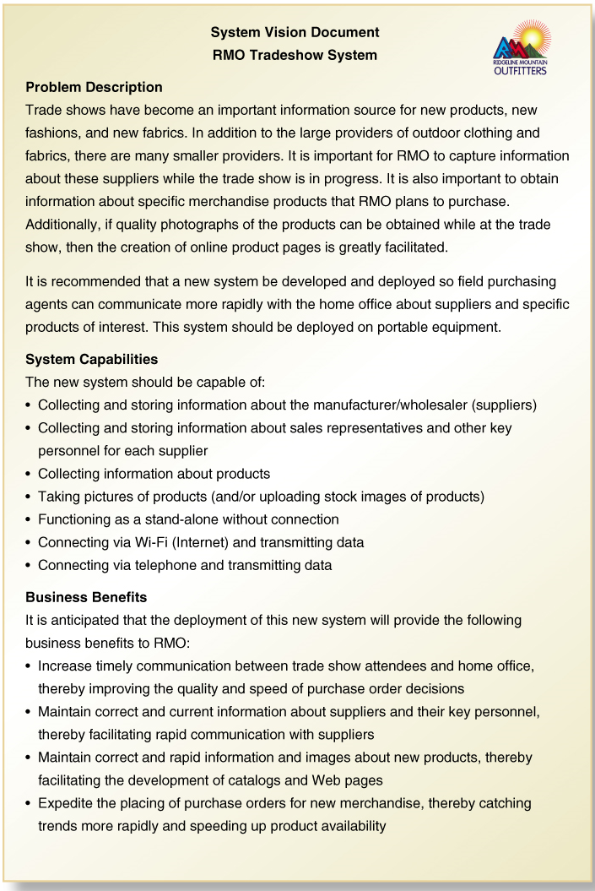



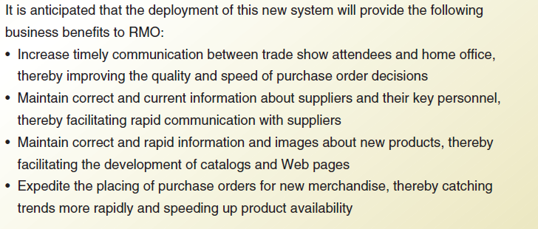

Use cases & Description (Table 1-11)

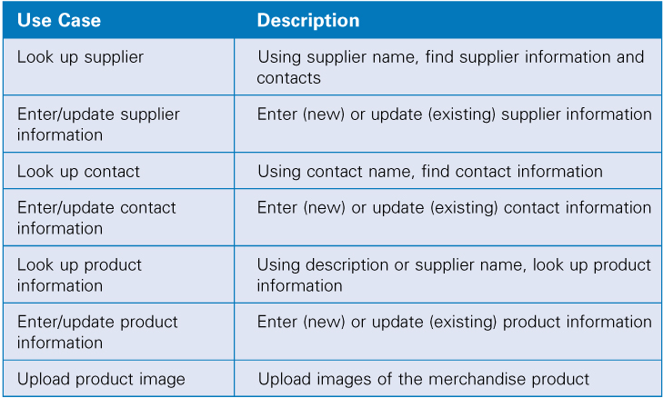

## Model user activities

Use case diagram

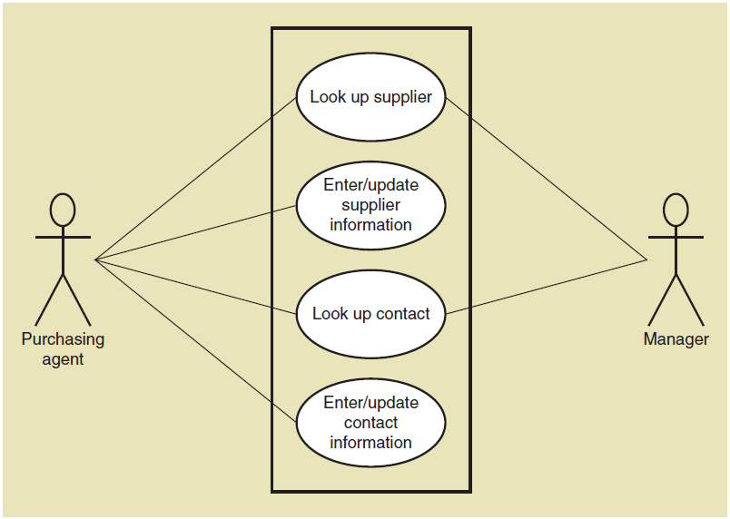

Workflows

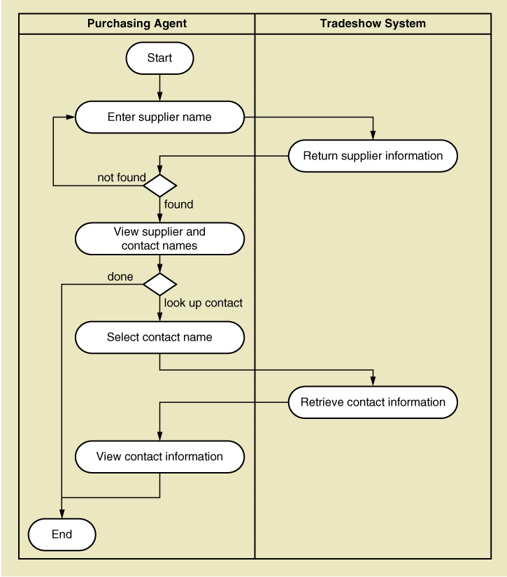

1-14, Domain Classes

**Application Components**

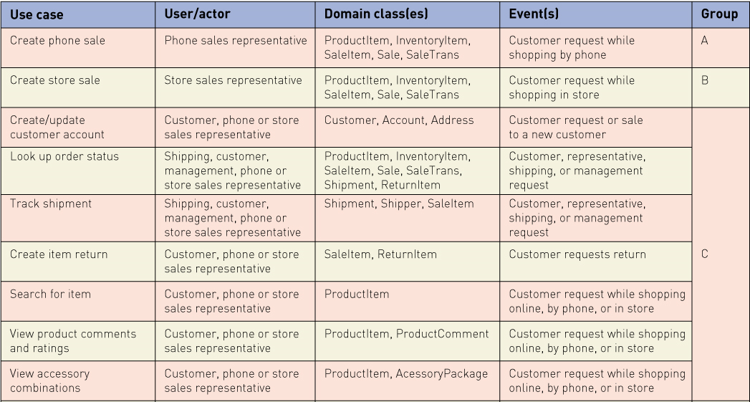

Identify Object Classes

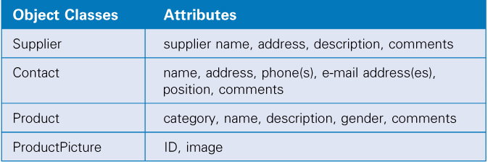

Class Diagram

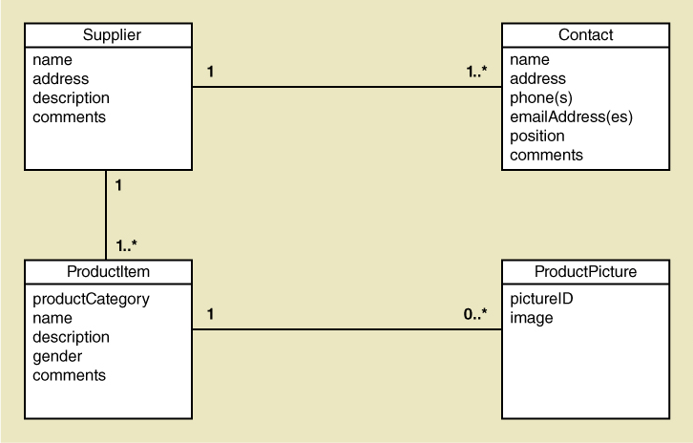





Activity and systems sequence diagrams, Workflows

Entity –Relationship Diagram

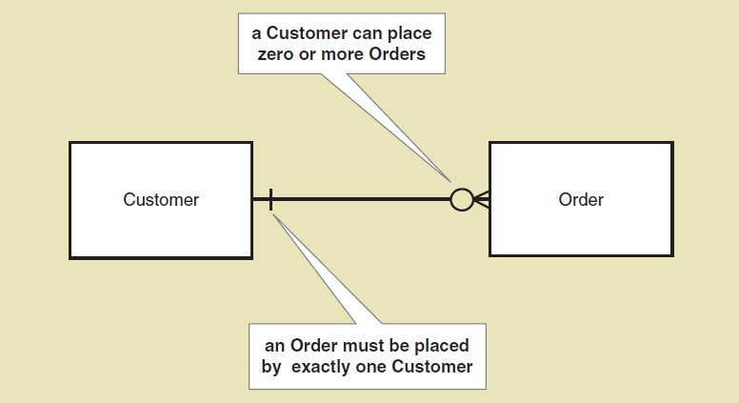





Design class diagram

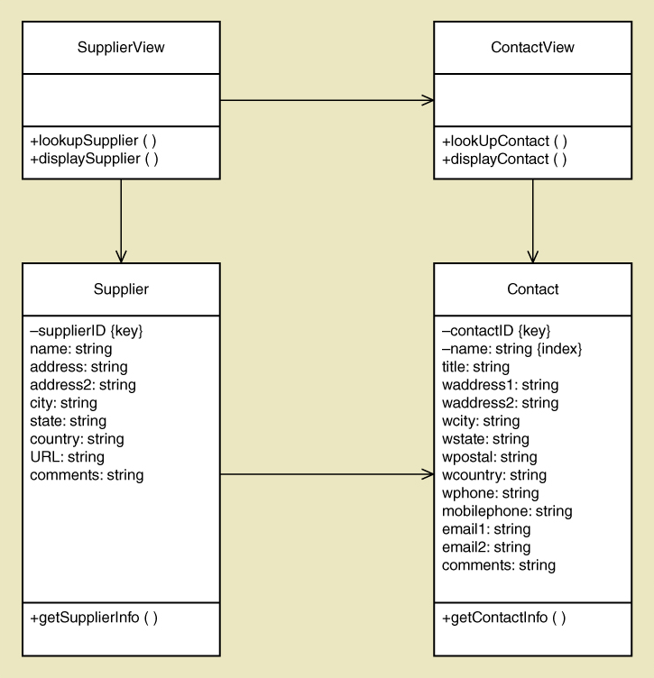

**Distributed Software Architectures**

**Three layer**

|  |  |  |  |  |  |
| --- | --- | --- | --- | --- | --- |
|  |  | **Actions** | **Function** | **Subsystem** | **MVC Pattern** |
| **1** | **User Interface** | **user request & formatted response** | **Format screens/reports** | **Client device** | **Each element:**  **View Logic /Layer**  **(Presentation/ Rendering – Html css, javascript)**  **Controller Layer**  **(Inputs/ Decision – process and respond to events and change view or model)**  **Reuseable Componets (View/Contoller Pair)** |
| **2** | **Domain**  **(Business Logic Layer)** | **Information request to, and unformatted response** | **Implements business rules** | **Web/Application server** | **Model Business logic /layer**  **(Objects (encapsulates data in database)** |
| **3** | **Data Layer** | **data access request & response** | **Formulates queries** | **Database server** |  |

[**http://www.w3schools.com/aspnet/mvc_intro.asp**](http://www.w3schools.com/aspnet/mvc_intro.asp)

**Lynda.com MVC Architecture**

1. **User interface/ View –**
2. **Domain/Business Logic**
3. **Data Layer –**

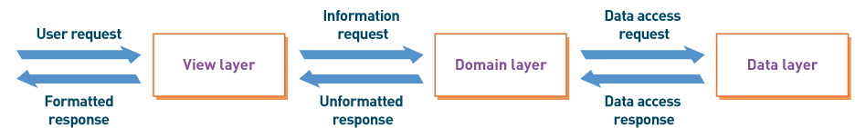

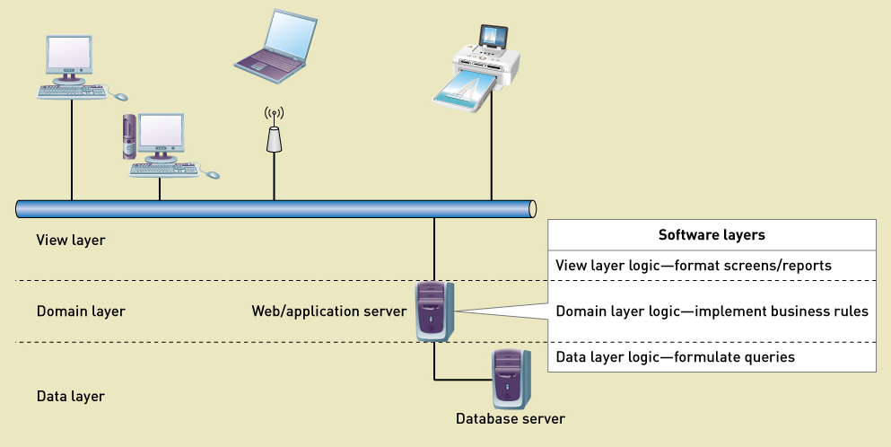

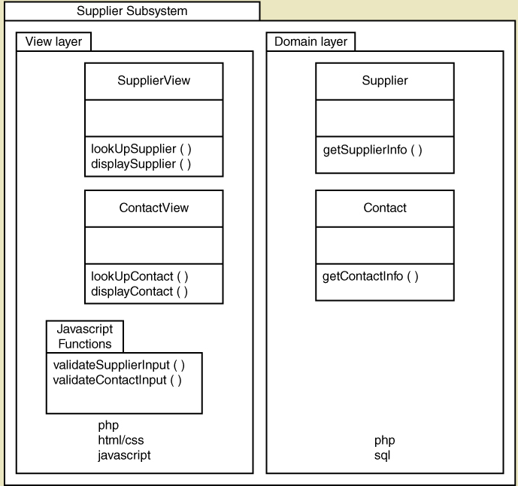

**Deployment diagrams**

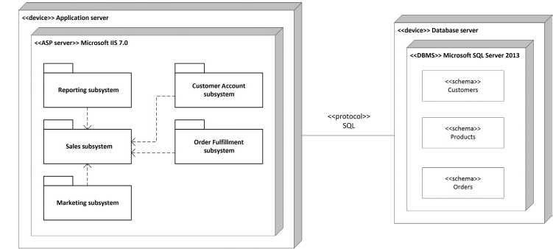

Architectural configuration

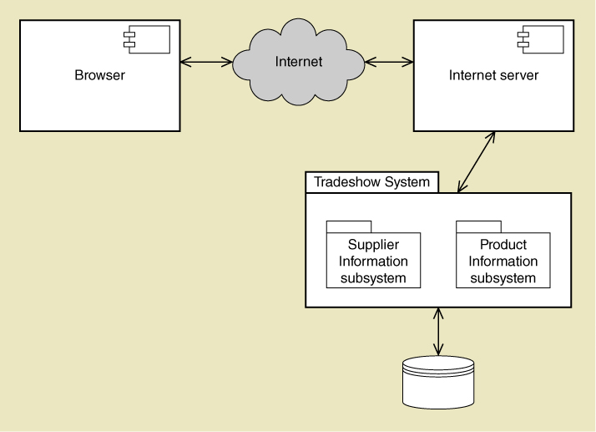

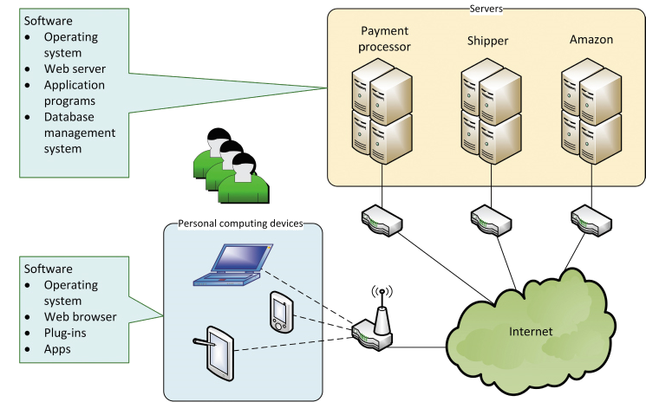

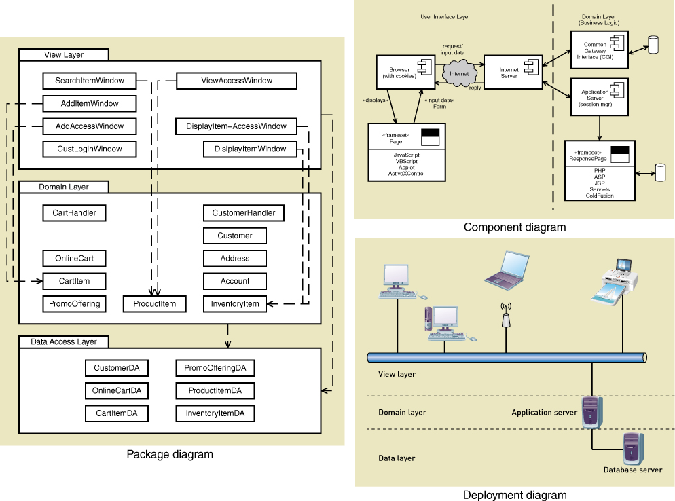

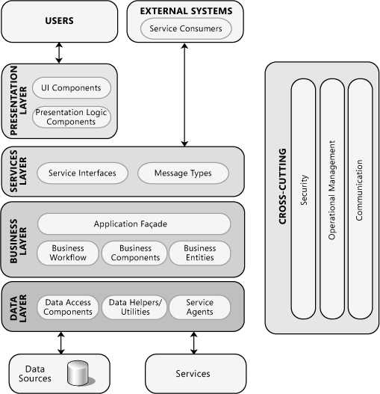

<https://msdn.microsoft.com/en-us/library/ee658124.aspx>

Architectural Patterns and Styles

* Client/Server Architectural Style
* Component-Based Architectural Style
* Domain Driven Design Architectural Style
* Layered Architectural Style
* Message-bus Architectural Style
* N-Tier / 3-Tier Architectural Style
* Object-Oriented Architectural Style
* Service-Oriented Architectural Style

**Whiteboard Your Architecture**

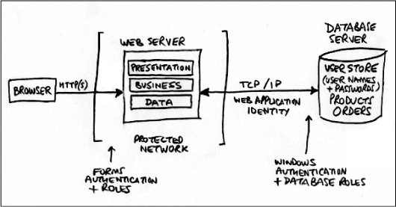

[**https://msdn.microsoft.com/en-us/library/ee658084.aspx**](https://msdn.microsoft.com/en-us/library/ee658084.aspx)

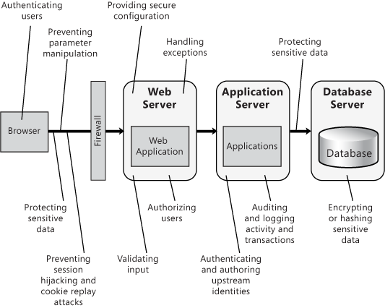

* Chapter 20 "[Choosing an Application Type](https://msdn.microsoft.com/en-us/library/ee658104.aspx)"
* Chapter 21 "[Designing Web Applications](https://msdn.microsoft.com/en-us/library/ee658099.aspx)"
* Chapter 22 "[Designing Rich Client Applications](https://msdn.microsoft.com/en-us/library/ee658087.aspx)"
* Chapter 23 "[Designing Rich Internet Applications](https://msdn.microsoft.com/en-us/library/ee658083.aspx)"
* Chapter 24 "[Designing Mobile Applications](https://msdn.microsoft.com/en-us/library/ee658108.aspx)"
* Chapter 25 "[Designing Service Applications](https://msdn.microsoft.com/en-us/library/ee658114.aspx)"
* Chapter 26 "[Designing Hosted and Cloud Services](https://msdn.microsoft.com/en-us/library/ee658110.aspx)"
* Chapter 27 "[Designing Office Business Applications](https://msdn.microsoft.com/en-us/library/ee658085.aspx)"

Chapter 28 "[Designing SharePoint LOB Applications](https://msdn.microsoft.com/en-us/library/ee658091.aspx)"

**Internet, Communications, Networks**

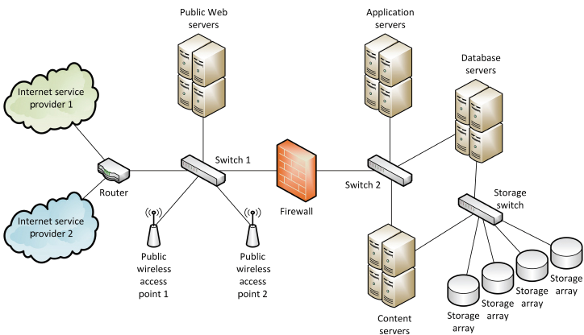

**System software**

**Application Software**

**Networking and protocols**

* [Jersey: RESTful Web Services in Java](https://jersey.java.net/)

Restlet API Platform

**Security**

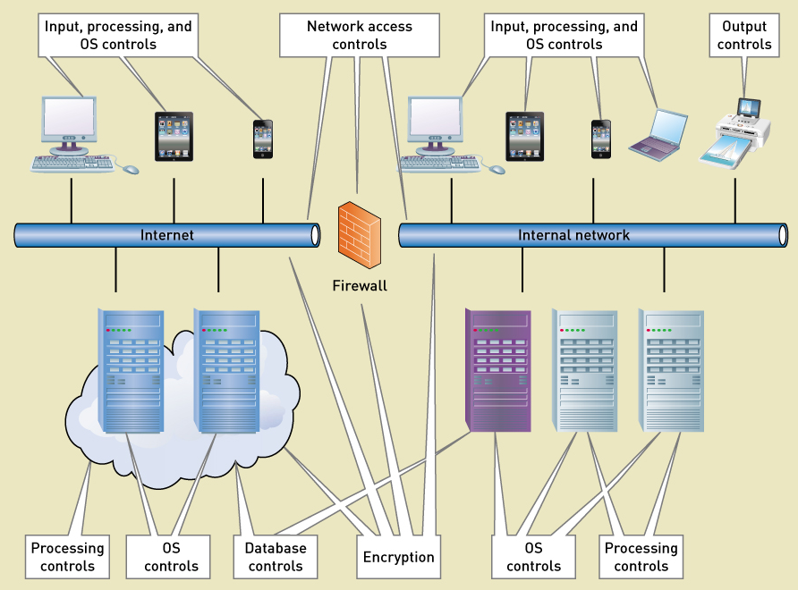

**Access controls**

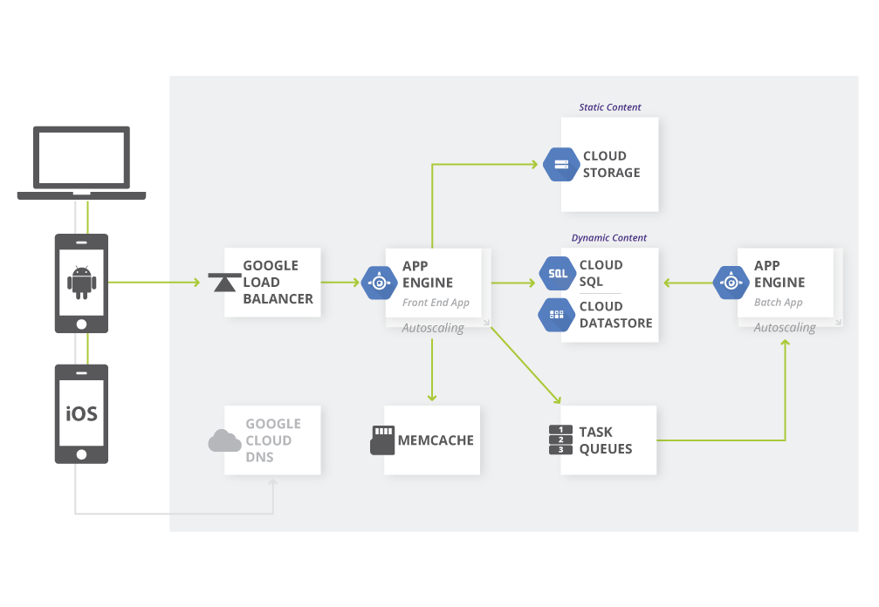

[**https://cloud.google.com/solutions/architecture/webapp**](https://cloud.google.com/solutions/architecture/webapp)

# Design

## Design database schema

Database schema

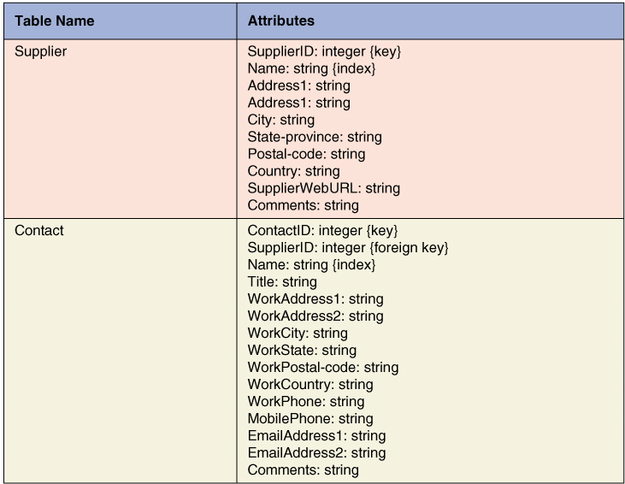

## Design screen layouts and cross links

User Experience

Screen layout

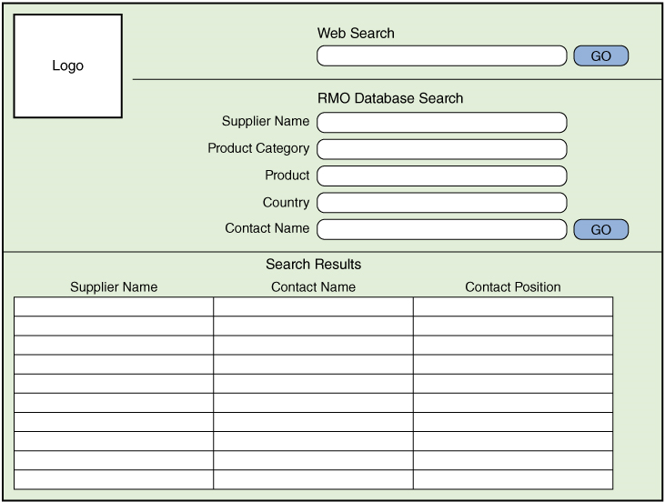

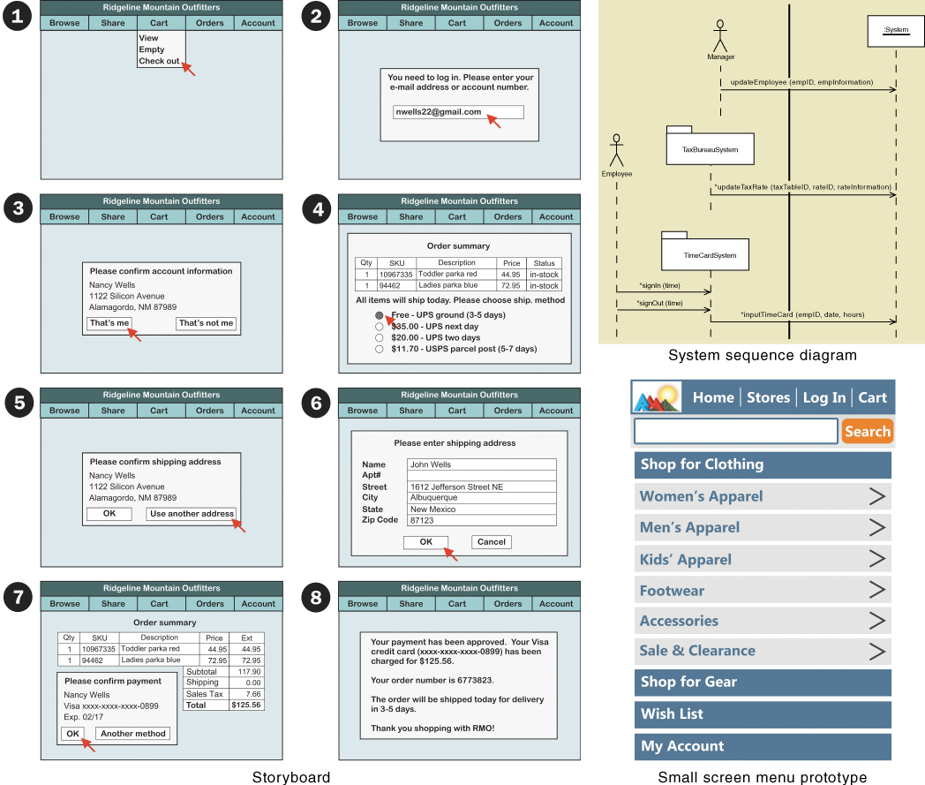

## Identify program classes and methods

# Build

Prototype the ap

Choose dev tools, framework and build

(Features: API, Simulator, Provisioning Tools, Compiler, IDE, Static Analysis tools, Profilers, UI builders, SDK management tools)

|  |  |
| --- | --- |
| Native SDK | iOS, Android |
| Cross-compile | Xamarin (C#), |
| Hybrid | PhoneGap |
| Container | Sencha (HTML5,CSS, Jvascript) |

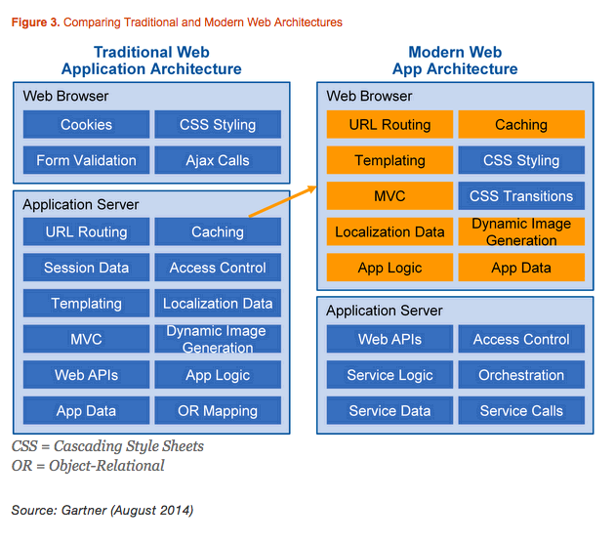

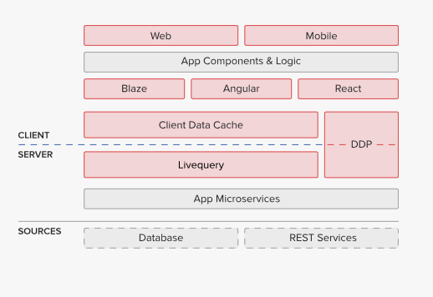

Meteor is also a hyper-efficient framework laying down 10 lines of code for what used to take 10K

|  |  |  |  |  |  |  |
| --- | --- | --- | --- | --- | --- | --- |
| Software Development Infrastructure  DevOps  ONE-COMMAND DEPLOY | Application Governance Infrastructure | Application Architecture |  | Cordova |  |  |
| Programming Language |  |  |  |  |
| Frameworks and Containers | UI | Node.js |  |  |
| Presentation Coordination |  |  |  |
| Service |  |  |  |
| Integration |  |  |  |
| Utility |  |  |  |
| Data Access | MongoDB |  |  |
| Runtime Infrastructure | Managed Communications Infrastructure | Google’s JavaScript runtime (V8). |  |  |
| Infrastructure Services Model | Docker containers,  Amazon EC2  1GB+ container size  1ECU+ compute unit  $250/10GB add-on RAM |  |  |
|  |  |  |  |  |  |  |
|  |  |  |  |  |  |  |

WebSockets, the persistent connections Meteor uses to sync data between clients

Easy deployment & scaling

runs critical apps in a HA configuration that keeps them up even in the event of an infrastructure failure.

24x7x365 critical issues

1hr critical support SLA

database of every client connected to your app

real-time metrics of exactly how many clients have an open WebSocket, even down to the individual container level

Coordinated version updates

Full Application logs

Full Container metrics

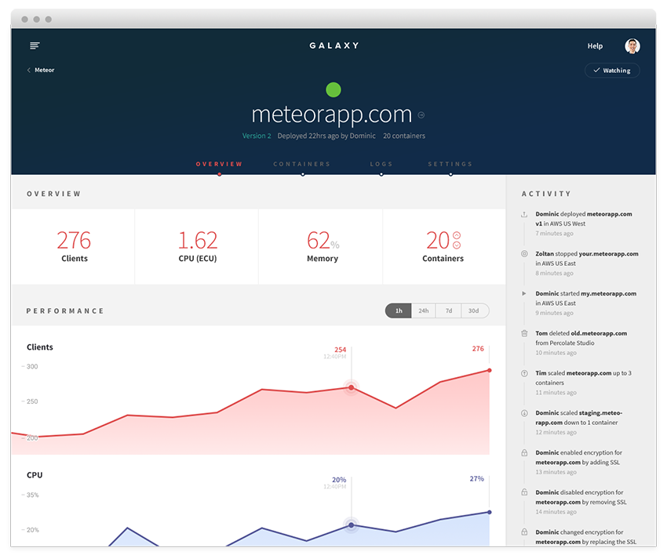

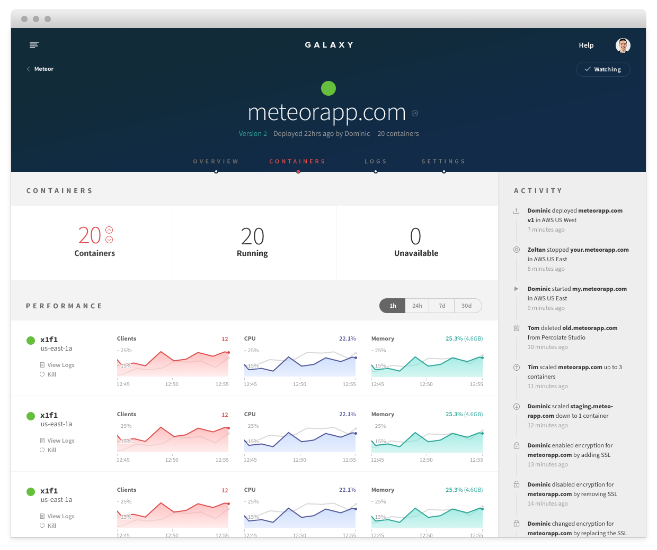

REAL-TIEM LOG POWERED BY ELASTIC SEARCH

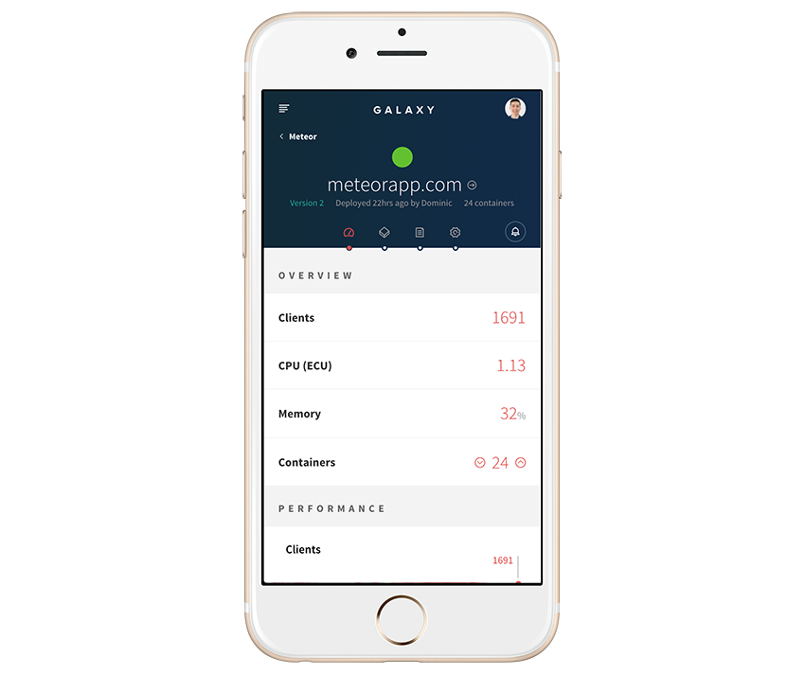

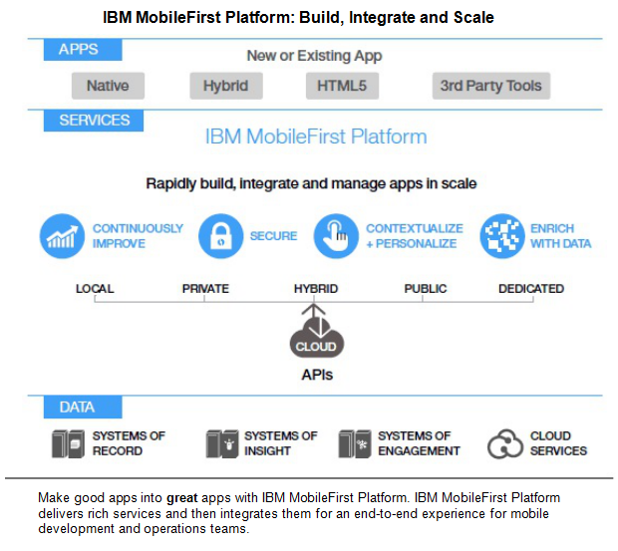

<http://www.ibm.com/developerworks/dwbooks/enterprise-mobile/index.html>

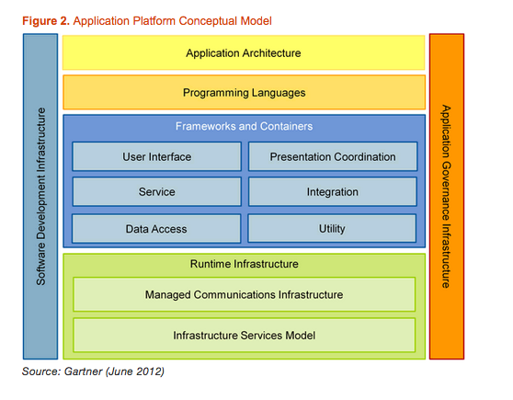

## Build database

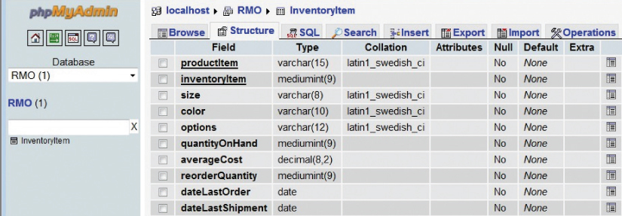

## Write Program Code

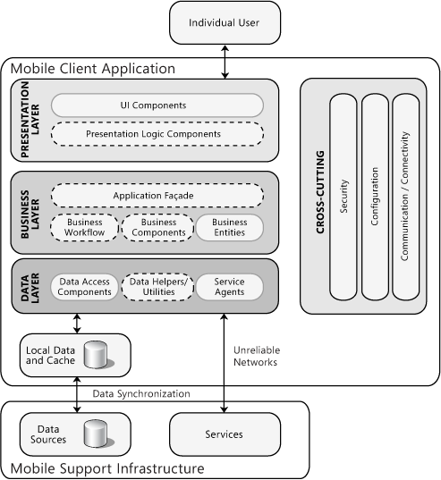

**Design Issues:**

* Authentication and Authorization
* Caching
* Communication
* Configuration Management
* Data Access
* Device Specifics
* Exception Management
* Logging
* Porting Applications
* Power Management
* Synchronization
* Testing
* User Interface
* Validation

<https://msdn.microsoft.com/en-us/library/ee658108.aspx#DesignConsiderations>

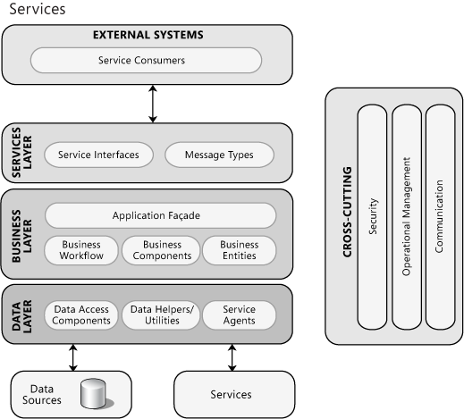

<https://msdn.microsoft.com/en-us/library/ee658114.aspx>

## Set up user simulate live environment

## Integrate components and proprietary logic/code

**Application Component integration**

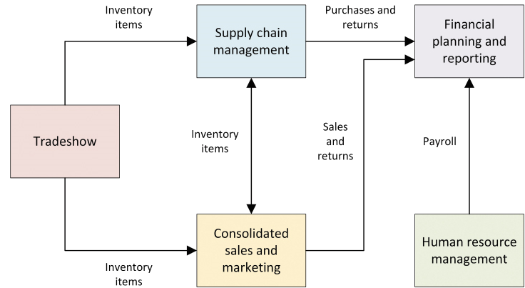

## Build test data

# Testing

Perform acceptance test with users

# Deployment

Release accepted version

Perform team introspection